Level 1
Task 2 Emulator vs Real Device
✅ Emulator vs Real Device in Android Development
🖥️ Emulator (Virtual Device)
A software-based Android device that runs on your computer.
✔ Advantages
- Free & easy to create multiple devices (different screen sizes, Android versions).
- No physical device required for testing.
- Fast iteration when using quick-boot or hot reload.
- Allows testing features like GPS, rotation, network speed, sensors using built-in controls.
- Supports snapshot so you can resume instantly.
✘ Disadvantages
- Slower performance compared to real devices (especially on low-spec PCs).
- Requires good hardware (RAM, CPU with virtualization).
- Cannot test:
  - Real-world battery drain
  - Actual camera quality
  - Fingerprint scanner accuracy
  - Bluetooth, NFC, hardware sensors, etc.
- Sometimes apps behave differently on emulator vs real phone.
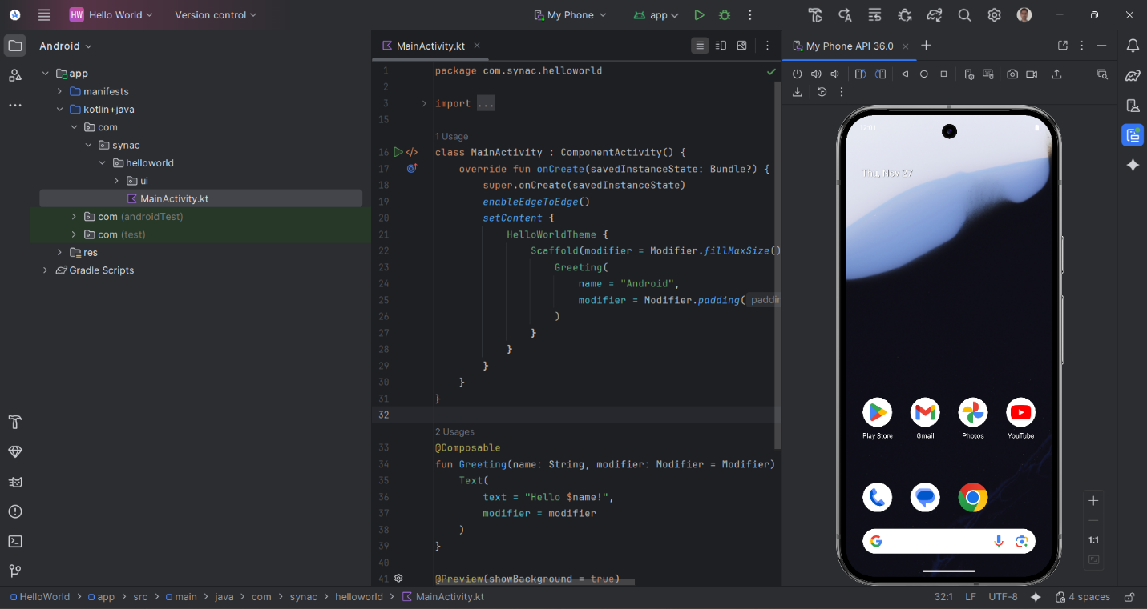
Figure 1: Emulator

📱 Real Device (Physical Android Phone)
A real smartphone connected via USB or Wi-Fi for testing.
✔ Advantages
- Fast & realistic performance since it’s actual hardware.
- Can test real sensors: camera, GPS, accelerometer, gyroscope, fingerprint, Bluetooth, NFC.
- Helps catch practical bugs that emulators miss.
- More reliable for UI/UX and performance testing.
✘ Disadvantages
- Requires an actual device (not free).
- Need to enable Developer Mode + USB Debugging.
- Hard to test multiple Android versions or screen sizes unless you have many devices.
- Physical devices can run out of battery or overheat.

⭐ Which should you use?
Purpose | Recommended
Initial development, UI testing, debugging | Emulator
Performance testing, hardware features, final QA | Real device
Testing on different Android versions | Emulator
Testing real user experience | Real device

🔥 Simple Recommendation
👉 Use Emulator for development.
👉 Use Real Device before releasing or submitting your app.

Emulator

